|  |
| --- |
| NAME: Ayush Vinod Upadhyay  ROLL NO: I025  SAP ID: 60003220131  BRANCH: Information Technology  BATCH: 1 |

**EXPERIMENT NO – 10**

**Aim:** To implement exceptions in Java (read input using DataInputStream/ BufferedReader classes)

**Problem Statement 1:** WAP to implement exception handling -default exceptions -NumberFormatException -ArithmeticException -ArrayIndexOutOfBounds

CODE:

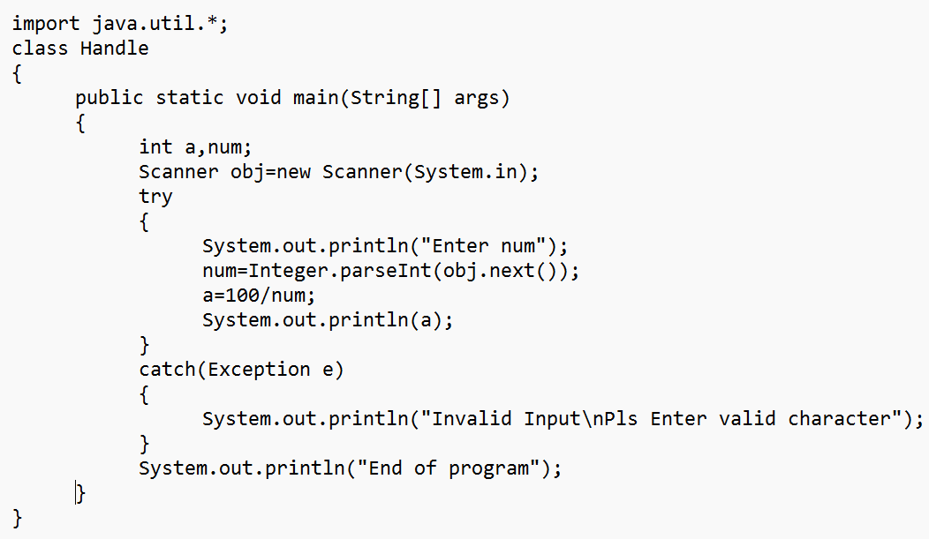

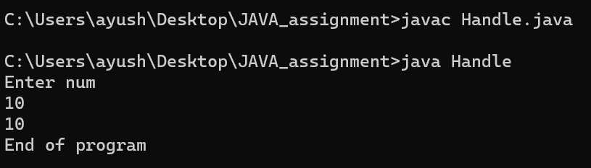

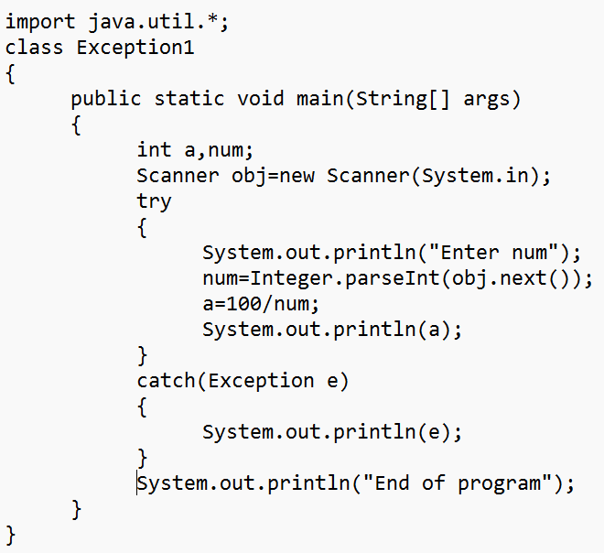

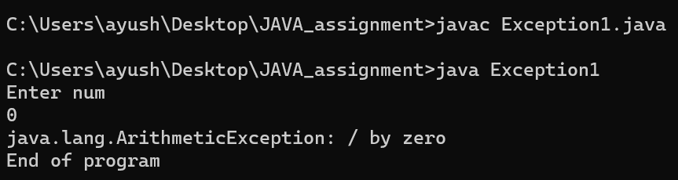



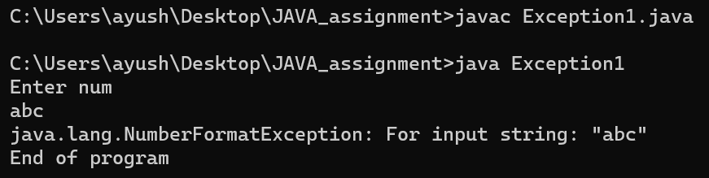

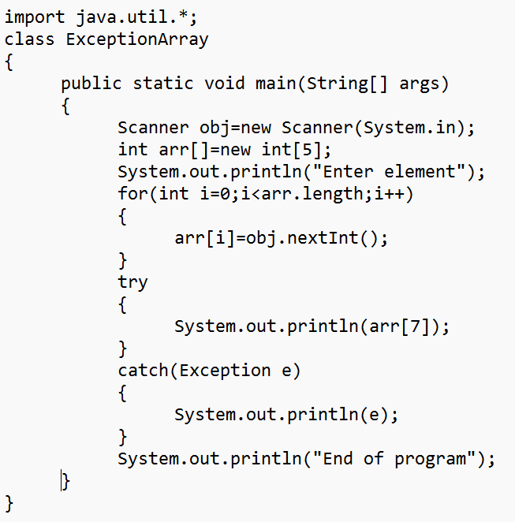

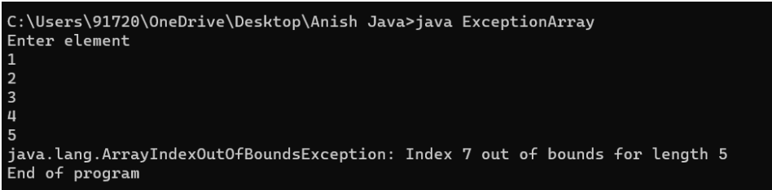

**Problem Statement 2:**

Write a Java Program to Create a User Defined Exception class MarksOutOfBoundsException, If Entered marks of any subject is greater than 100 or less than 0, and then program should create a user defined Exception of type MarksOutOfBoundsException and must have a provision to handle it

CODE:

